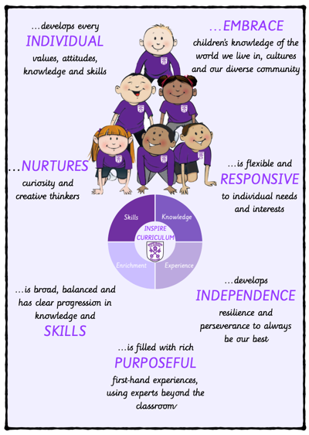 | …develops every INDIVIDUAL values, attitudes, knowledge and skills | …NURTURES curiosity and creative thinkers | …is broad, balanced and has clear progression in knowledge and SKILLS
 | Knowledge Organisers make clear links to locality and the wider world. Promotes open-mindedness and critical thinking through understanding diverse perspectives and global issues.  Children are prepared for the next stage of learning through sequential and coherent curriculum.  Encourages respect for cultures and the environment, developing empathy and social responsibility. | Children understand that knowledge and skills consistently applicable to their understanding of the world around them.  Stimulates curiosity about the world through hands-on learning (fieldwork, map studies, and environmental observation).  Encourages creative thinking to address global issues like climate change, urbanization, and conservation. | Knowledge Organisers provide graphic representations of the key knowledge, vocabulary and images required to form a scheme of learning.  Learning through three key strands of study: geographical skills and fieldwork, global and human/physical geography.  Integrates theory with practical skills, such as map reading, fieldwork, and data analysis, allowing students to apply knowledge.  Develops complexity over time, advancing from basic geographical concepts in early years to more detailed exploration of global systems, places, and environments in later years.
…is filled with rich PURPOSEFUL first-hand experiences, using experts beyond the classroom | …develops INDEPENDENCE resilience and perseverance to always be our best | …is flexible and RESPONSIVE to individual needs and interests | …EMBRACE children’s knowledge of the world we live in, cultures and our diverse community
Local enrichment opportunities deepen children’s learning through fieldwork and an experience in alternative landscapes.  Children have the opportunity to use relevant equipment to measure, record and present human and physical features. | Retrieval activities develop independent learners by supporting the development of their long-term memory.  Through the use of a range of tasks children develop perseverance in their learning.  Encourages independent research and exploration, enabling students to take ownership of their learning about different regions and cultures. | New learning is presented in small steps with clear explanations and narratives from the teacher.  Modelling and guided practise scaffold pupils learning before moving into guided practise to ensure the key knowledge is embedded.  Adapts to different learning styles and abilities, with flexible methods such as visual aids (maps, diagrams), practical activities (fieldwork), and discussions.  Encourages students to link geography to their own experiences, interests, or backgrounds, making learning relevant and engaging. | Broadens understanding of global diversity by exploring different cultural practices, traditions, and ways of life, fostering respect and inclusion.  Geography concepts contributes towards children’s understanding of the wider world, the impact humans can have and appreciation for a range of cultures.  Connects local geography to global issues, encouraging students to reflect on their own place in the world and how communities are interlinked.

