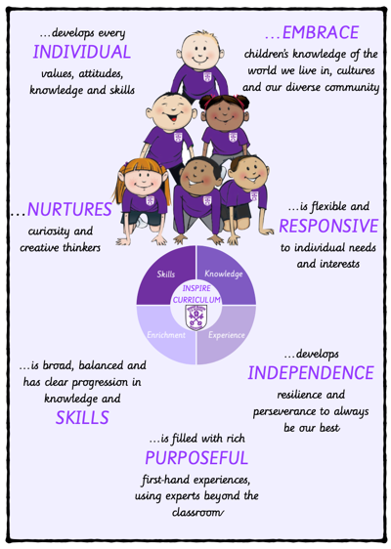 | …develops every INDIVIDUAL values, attitudes, knowledge and skills | …NURTURES curiosity and creative thinkers | …is broad, balanced and has clear progression in knowledge and SKILLS
 | Children are taught to ask questions, think critically, weigh evidence, sift arguments, and develop perceptive and judgement. Builds a foundation of historical knowledge (key events, figures, and timelines) while developing skills in research, analysis, and interpretation of sources.  Children are prepared for the next stage of learning through sequential and coherent curriculum.  Knowledge Organisers make clear links to locality and the wider world.  Encourages critical thinking about historical events and their impact on society, cultivating a reflective attitude towards past and present issues | Stimulates curiosity through questions about the past, encouraging students to explore and investigate historical mysteries and themes.  Children understand that knowledge and skills gained in history lessons are consistently applicable to everyday life.  Encourages students to draw parallels between historical events and contemporary issues, developing a deeper understanding and stimulating further inquiry. | Children are introduced to key knowledge, concepts and significant individuals in Key Stage 1, and expand on these in more depth in Key Stage 2  Prior learning is outlined to support teachers to build on what children already know.  Retrieval practice allows children to commit key knowledge to memory.  Covers a wide range of topics, including ancient civilizations, significant events, and social changes, providing students with a well-rounded understanding of history.  Develops historical skills progressively, starting with basic understanding in earlier years (like timelines and significant figures) and advancing to more complex concepts (like cause and effect, historical interpretation) in later years.
…is filled with rich PURPOSEFUL first-hand experiences, using experts beyond the classroom | …develops INDEPENDENCE resilience and perseverance to always be our best | …is flexible and RESPONSIVE to individual needs and interests | …EMBRACE children’s knowledge of the world we live in, cultures and our diverse community
First hand experiences provide an explicit links to Liverpool’s rich history.  Access to first hand experiences address gaps in understanding and allow for real world application of knowledge. | Retrieval activities develop independent learners by supporting the development of their long-term memory.  Through the use of a range of tasks children develop perseverance in their learning.  Engages students in discussions about complex historical issues, encouraging them to persevere in developing their arguments and understanding differing perspectives. | Children can express themselves through homework projects that allow them to share their learning a range of ways.  New learning is presented in small steps with clear explanations and narratives from the teacher. | Children learn about history in our local area whilst also developing their understanding of history in a range of cultures across the world.  Integrates studies of local and global cultures, highlighting contributions from diverse communities and encouraging students to share their backgrounds.  Children learn about key historical concepts, allowing them to develop schema that links historical knowledge about different cultures and time periods.

