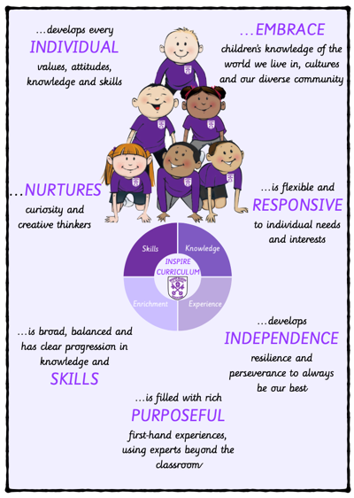 | …develops every INDIVIDUAL values, attitudes, knowledge and skills | …NURTURES curiosity and creative thinkers | …is broad, balanced and has clear progression in knowledge and SKILLS
 | Develop a love of literature through widespread reading for purpose and pleasure.  Oracy underpins the development of reading and writing and allows pupils to immerse themselves in books.  Fluency in the English language is an essential foundation for success in all subjects. | Pupils confidently use reading skills to enhance their learning across all areas of the curriculum.  Pupils will have a keen interest in words and will draw on a range of authors and poets to support their own written work across a range of genres.  Retrieval practice built into every lesson engage all pupils to nurture their thinking. | Progression in reading and writing clearly mapped out from EYFS to Y6.  Knowledge Organisers support pupils in knowing more and remembering more.  Oracy skills developed through the listening ladder, discussion, debating and presenting.
…is filled with rich PURPOSEFUL first-hand experiences, using experts beyond the classroom | …develops INDEPENDENCE resilience and perseverance to always be our best | …is flexible and RESPONSIVE to individual needs and interests | …EMBRACE children’s knowledge of the world we live in, cultures and our diverse community
Author workshops and visits develop reading for pleasure and knowledge across the curriculum.  High aspirations encouraged for ALL pupils through access to a wide range of texts, classic literature and educational visits.  Special reading and writing events showcase and celebrate a love of literature in the wider world. | A rigorous and sequential approach to the teaching of systematic phonics (Read Write Inc) develops fluency in reading.  Use of working walls and analysis of model and vehicle texts encourages independent writing.  Reading books are carefully matched to pupils’ reading attainment, and ZPDs used to develop independent reading choices. | Purposeful and responsive to the needs of ALL pupils, enriching knowledge and skills across the curriculum.  Reading interventions provided to support pupils and ensure good progress is made.  Range of genres and texts covered based on children’s interests and experiences. | Reading curriculum carefully mapped out to ensure pupils encounter a diverse range of texts.  Through reading, pupils inhabit the lives of those who are like them, but also explore the lives and perspectives of those who differ from their own.  Pupils encouraged to reflect on our Christian Values within English, reading and story time sessions across the curriculum.

